CMPS310 Software Engineering
- Group project –
Fall 2026
Milestone 1: Software Requirements Analysis and Design

Effort distribution of the students:

SID: 202203692 STUDENT NAME: Hanin Ahmed Effort given: 25 %
SID: 202303976 STUDENT NAME: Reem Almarri Effort given: 25 %
SID: 202209732 STUDENT NAME: Jawaher Sarhan Effort given: 25 %
SID: 201903017 STUDENT NAME: Rana Al-Dosari Effort given: 25 %

Course number: 310

Submission date: 18/10/2026
Theory Class section: L51

DECLARATION: We hereby certify that no part of this project or product has been copied from any other student’s work or from any other sources except where due acknowledgment is made in the project. No part of this project/product has been written/produced for us by any other persons.

Topic | Page number
Project description | 3
Data Flow Diagram (DFD) – Level 0 | 4
Data Flow Diagram (DFD) – Level 1 | 5
Data Flow Diagram (DFD) – Level 2 | 6
DFD Balancing Verification | 7-8
Use Case Diagram (UCD) | 9-10
DFD and Use Case Diagram Comparison | 11
Use Case Specifications | 12-15
Design Class Diagram | 16-17
Scrum & GitHub Project Management | 18
Assumptions & Requirements Traceability | 19-21
Conclusion | 22

- Project description:
PearlMart Inventory Management System is an automated system designed to manage the inventory activities of a retail store. The system aims to replace manual procedures, reduce human errors, and maintain accurate and consistent inventory information. It operates as one integrated system across the warehouse and billing counters.
The system provides several main functionalities, including user authentication, managing user accounts, adding and updating items, managing stock quantities, identifying expired products, placing supplier orders, receiving goods, processing sales transactions, handling cancellations and product replacements, recording customer requests for unavailable items, and generating management reports.
The system is used by four types of employees: Administrator, Inventory Manager, Store Manager, and Salesperson. It also communicates with external Suppliers to exchange purchase orders, invoices, and delivery information.
In this milestone, Data Flow Diagrams (DFD), a Use Case Diagram, four complex Use Case Specifications, and a Design Class Diagram are developed to represent the system's requirements and design. Scrum and GitHub are also used to plan, organize, and track the project's progress.

- Data Flow Diagram (DFD):

2.1- Level 0:
The Level 0 Data Flow Diagram provides an overview of the PearlMart Inventory Management System and its interactions with external entities. The entire system is represented as a single process (Process 0), which receives requests and information from users and suppliers, processes them, and returns the appropriate results.
The system interacts with five external entities: Administrator, Inventory Manager, Store Manager, Salesperson, and Supplier.

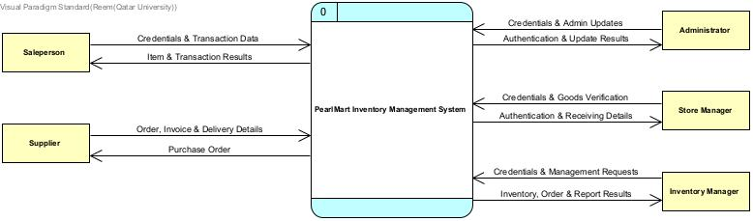

Figure 1: Data Flow Diagram of the system

Processes | External entities | Data Stores
0.0 PearlMart Inventory Management system | Salesperson | None
 | Supplier
 | Administrator
 | Store Manager
 | Inventory Manager

2.2- Level 1
The Level 1 Data Flow Diagram decomposes the PearlMart Inventory Management System into six main processes. Each process is responsible for a specific system function, including user authentication, inventory management, supplier orders, sales transactions, product replacements, customer requests, and report generation.
The diagram also introduces six data stores that maintain information required for system operations. External entities communicate with these processes through data flows, while the processes read and update the relevant data stores.

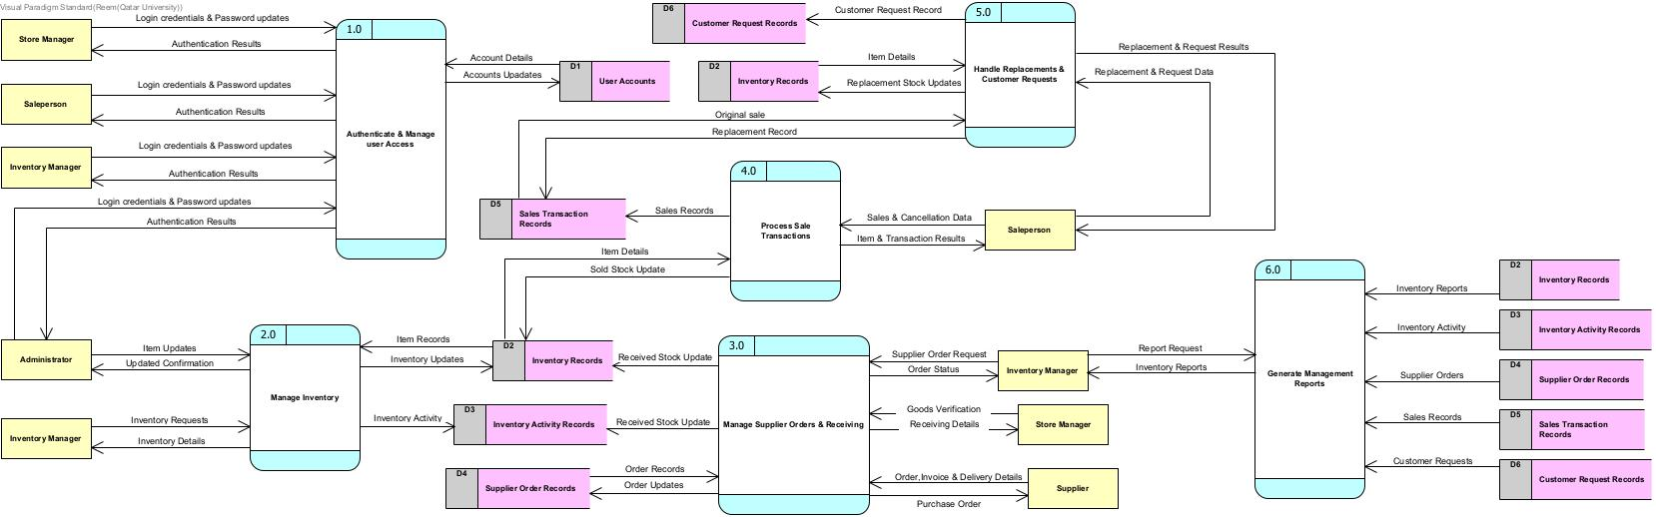

Figure 2: Data Flow Diagram of the system

Processes | External entities | Data Stores
1.0 Authenticate & Manage User Access | Salesperson | D1 User Accounts
2.0 Manage Inventory | Supplier
  D2 Inventory Records
3.0 Manage Supplier Orders & Receiving | Administrator
  D3 Inventory Activity Records
4.0 Process Sales Transactions | Store Manager | D4 Supplier Order Records
5.0 Handle Replacements & Customer Requests | Inventory Manager | D5 Sales Transaction Records
6.0 Generate Management Reports |  | D6 Customer Request Records

2.3- Level 2
The Level 2 Data Flow Diagram provides a detailed decomposition of Process 4.0, Process Sales Transactions, into five subprocesses.
The sales process begins when the Salesperson enters sale or cancellation data. The system retrieves the selected item's information, validates the available quantity, and calculates the sale amount. Based on the transaction details, the system either completes or cancels the transaction.
For completed sales, the system generates a receipt, updates the inventory records, and stores the sales transaction. Cancellation or validation failure results are returned to the Salesperson without processing a completed sale.
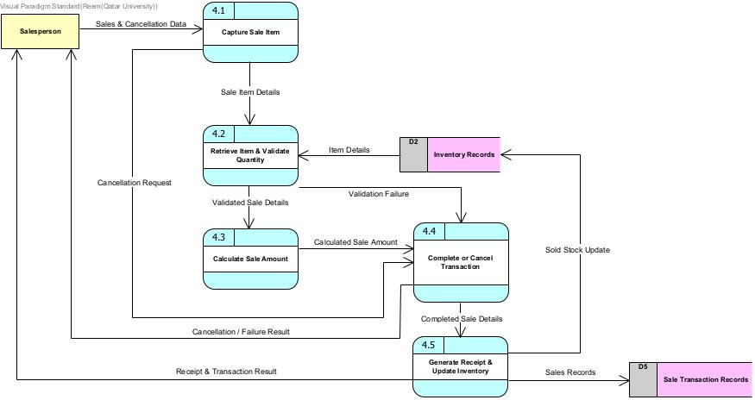

Figure 3: Data Flow Diagram of the system

Processes | External entities | Data Stores
4.1 Capture Sale Item | Salesperson
  D2 Inventory Records
4.2 Retrieve Item & Validate Quantity
  D5 Sales Transaction Records
4.3 Calculate Sale Amount
4.4 Complete or Cancel Transaction
4.5 Generate Receipt & Update Inventory

3- DFD Balancing Verification
- Balancing Between Level 0 and Level 1
Level 0 represents the PearlMart Inventory Management System as one process, while Level 1 decomposes it into six major processes. The following table compares the external data flows at both levels.

External Entity | Level 0 Data Flows | Corresponding Level 1 Processes | Balancing Result
Administrator | Login Credentials / Password Change / Inventory Update Data; Authentication Result / Update Confirmation | 1.0 – Authenticate & Manage User Access; 2.0 – Manage Inventory | Balanced — login/authentication and inventory update flows are represented in both levels.
Inventory Manager | Login Credentials / Password Change / Inventory, Order & Report Requests; Authentication / Inventory & Expired-Goods Information / Order Status & Customer-Request Summary / Reports | 1.0 – Authenticate & Manage User Access; 2.0 – Manage Inventory; 3.0 – Manage Supplier Orders & Receiving; 6.0 – Generate Management Reports | Balanced — the aggregated management requests and results are decomposed into their respective functions.
Store Manager | Login Credentials / Delivery & Receiving Information; Authentication Result / Delivery & Receiving Confirmation | 1.0 – Authenticate & Manage User Access; 3.0 – Manage Supplier Orders & Receiving | Balanced — login, goods verification, and receiving confirmation are represented.
Salesperson | Login / Password Data / Sales, Replacement, Customer-Request & Completion-Decision Data; Authentication / Availability & Sale Amount / Receipt & Transaction Result / Replacement & Request Result | 1.0 – Authenticate & Manage User Access; 4.0 – Process Sales Transactions; 5.0 – Handle Replacements & Customer Requests | Balanced — authentication, sales, and replacement/customer-request flows are represented.
Supplier | Purchase Order Details; Order Response / Invoice / Delivery Information | 3.0 – Manage Supplier Orders & Receiving | Balanced — supplier ordering and incoming information are represented with matching directions.

Level 0 – Level 1 Balancing Statement
The Level 1 DFD preserves the external interactions represented in the Level 0 context diagram. The aggregated data flows in Level 0 are distributed among the six Level 1 processes according to their responsibilities. Internal data stores and their related flows are introduced only in Level 1 and do not change the external system boundary.

- Balancing Between Level 1 and Level 2

Level 2 decomposes Process 4.0 – Process Sales Transactions into five subprocesses (4.1–4.5).

# | Level 1 Boundary Flow | Corresponding Level 2 Flow | Balancing Result
1 | Salesperson → 4.0: Sales & Cancellation Data | Salesperson → 4.1: Sales & Cancellation Data | Balanced
2 | D2 → 4.0: Item Details | D2 → 4.2: Item Details | Balanced
3 | 4.0 → D2: Sold Stock Update | 4.5 → D2: Sold Stock Update | Balanced
4 | 4.0 → D5: Sales Records | 4.5 → D5: Sales Records | Balanced
5 | 4.0 → Salesperson: Item & Transaction Results | 4.4 → Salesperson: Cancellation / Failure Result; 4.5 → Salesperson: Receipt & Transaction Result | Balanced — one parent flow is represented by two outcome-specific flows in Level 2.

Level 1–Level 2 Balancing Statement:
The Level 2 DFD preserves the five boundary data flows of Process 4.0 from Level 1. It provides additional internal details about item capture, quantity validation, sale amount calculation, transaction completion or cancellation, receipt generation, and inventory updates.
The internal flows between subprocesses do not cross the parent process boundary and therefore do not require corresponding flows in Level 1.
Overall Balancing Conclusion
The proposed DFD decomposition maintains consistency between the context diagram, the major system processes, and the detailed sales transaction process.
Level 0 summarizes the system’s external interactions, Level 1 distributes those interactions among the major processes, and Level 2 further explains the internal processing of sales transactions while preserving the parent process’s external data flows.

4-Use Case Diagram (UCD):
UC Description: The Use Case Diagram illustrates the main functions of the PearlMart Inventory Management System and the interactions between actors and the system. It includes 20 use cases covering user authentication, inventory management, supplier orders, sales transactions, product replacements, and management reports. The diagram also shows the relationships between use cases, including include, extend, and actor generalization.

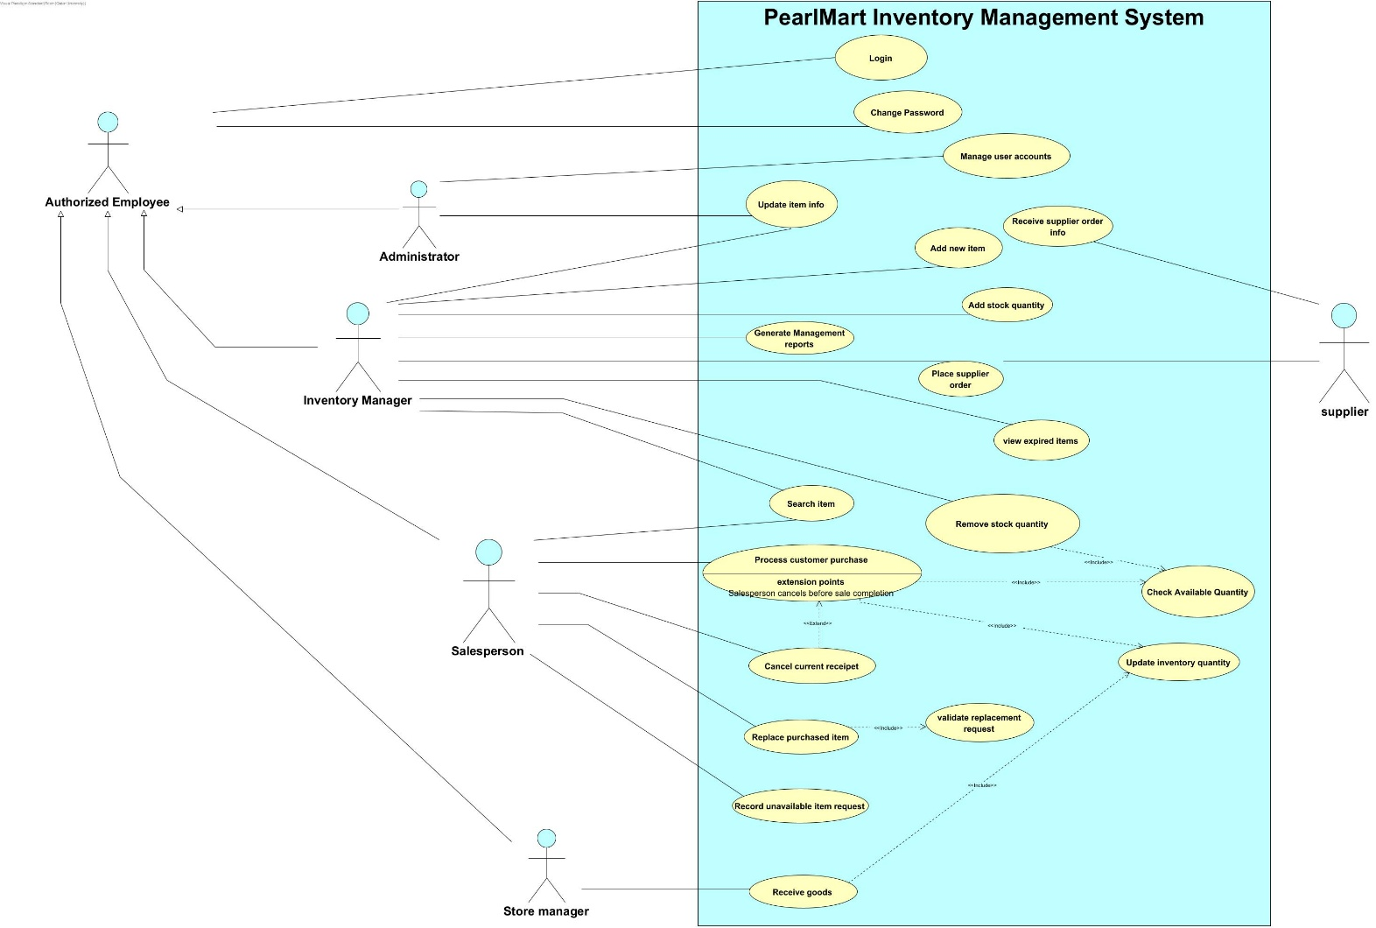

Figure 4: Use case diagram of the system

Table: Use Cases and Descriptions

Use Case | Description
Login | Authenticates employees before granting access to the system
Change Password | Allows authorized employees to change their passwords
Manage User Accounts | Allows the Administrator to manage employee accounts
Update Item Info | Updates existing product information
Add New Item | Creates a new inventory record for a product
Add Stock Quantity | Increases the available quantity of an existing item
Remove Stock Quantity | Validates and removes a specified quantity from inventory
View Expired Items | Displays products that have passed their expiration dates
Search Item | Searches for an item and retrieves its information
Generate Management Reports | Generates summaries of inventory activities and transactions
Place Supplier Order | Creates and submits a purchase order to a supplier
Receive Supplier Order Info | Receives supplier order, invoice, and delivery information
Receive Goods | Receive Goods: Records received goods and updates stock quantities
Process Customer Purchase | Validates purchased items, calculates the total, records the sale, and generates a receipt
Cancel Current Receipt | Cancels a sales transaction before completion
Check Available Quantity | Checks whether the requested stock quantity is available
Update Inventory Quantity | Updates inventory quantities after transactions
Replace Purchased Item | Validates and processes replacement requests for purchased items
Validate Replacement Request | Checks whether a requested product replacement is permitted
Record Unavailable Item Request | Records customer requests for products that are currently unavailable

5-DFD and Use Case Diagram Comparison
The DFD and the use case diagram show different things about PearlMart. The DFD focuses on data. It shows the six main processes, the six data stores (such as Inventory Records and Sales Transaction Records), and how data moves between the processes, the stores, and the external entities like the Supplier. The use case diagram focuses on users. It shows who uses the system (Salesperson, Inventory Manager, Store Manager, Administrator, and Supplier) and what each of them can do, like “Process customer purchase” or “Place supplier order”.
Each diagram is strong where the other is weak. The use case diagram clearly shows the roles and the functions, so it helps us check that all the client’s requirements are covered. But it does not show what data is stored or how it is shared. The DFD shows the data and the stores, but it does not show which user is allowed to do which task, and it does not show rules like what happens when the quantity is not available. Because of this, we need written use case specifications to add the details.
For analyzing PearlMart, the DFD is more useful. Ms. Sara wants the information to stay consistent whether the work is done in the warehouse or at the billing counter. In our DFD, the Inventory Records store (D2) is updated by processes 2.0, 3.0, 4.0, and 5.0, so it is easy to see that all of them must update the same data. The use case diagram does not make this clear, and it even missed that “Replace purchased item” must update the inventory. So the DFD is better for this question, and the use case diagram is better for roles and functions. We need both to understand the system well.

6-Use Case specifications:

Use case ID: UC001 | Use case title: Process Customer Purchase
Brief Description | The salesperson processes the item a customer selects at the billing counter. The system calculates the final amount, generates a receipt, and deducts the purchased quantities from the inventory when the sale is completed.
Primary actors | Salesperson
Trigger | A customer arrives at the billing counter with items to purchase and the salesperson starts a new sale.
Preconditions:
- The salesperson must be an authorized employee with an account.
- The salesperson must be logged in

Post-conditions:
- The sale was recorded.
- The receipt was generated with the purchased items, quantities, prices, discounts, taxes, and final amount.
- The quantities of the purchased items were deducted from the inventory.

Main Success Scenario
Actor Action |  | System Response
- The salesperson starts a new sale. |  | - Create a new current receipt.
- The salesperson scans the item’s barcode or enters its identifier and specifies the quantity purchased |  | - Retrieve the item information (see 4.a)
 |  | - <include: Check Available Quantity> for the requested quantity (see 5.a)
 |  | - Calculate the item selling amount (applying discounts and taxes where applicable), add the item to the receipt, and display the running total.
 |  | - <extend: Cancel current receipt> if the salesperson cancels before sale completion.
8- The salesperson repeats steps 3-6 for every item, then indicates that all items are entered. |  | - Calculate and display the final amount to be paid.
 |  | - Generate the receipt.
 |  | - Record the sale.
 |  | - <include: Update inventory quantity> to deduct the purchased quantities.
 |  | - Display a completed sale message.
Alternative flows:
4.a If the item is not found, display an error message and return to step 3.
5.a. If the requested quantity is greater than the available quantity, display the available quantity, reject the item, and return to step 3.

Use case ID: UC002 |  | Use case title: Place Supplier Order
Brief Description
  The Inventory Manager orders goods from an external Supplier. The system records the supplier order, forwards it to the Supplier, and records the order information and invoice received from the Supplier.
Primary actors | Inventory Manager (secondary actor: Supplier)
Trigger | The Inventory Manager decides that additional goods are needed.
Preconditions:
1- The Inventory Manager must be logged in and authorized to place supplier orders.
2- The Supplier must be registered in the system.
Post-conditions:
1- The supplier order is recorded in the supplier order records with a unique order ID, date, items, quantities, delivery address, contact information, comments, and status “Sent”.
2- The supplier order information is forwarded to the Supplier.
3- The Supplier’s ordered-goods information and invoice are recorded and linked to the supplier order.
4- Inventory quantities are unchanged until the goods are received (see Receive goods).
Main Success Scenario
Actor Action |  |  | System Response
1- The Inventory Manager selects “Place Supplier Order”. |  |  | 2- The system displays the order form and the list of Suppliers and the recorded customer requests.
3- The Inventory Manager selects a Supplier. |  |  | 4- The system retrieves and displays the Supplier’s details.
5- The Inventory Manager scans or enters the item identifier and the required quantity. |  |  | 6- The system retrieves the item information from the inventory records, validates the quantity, and adds the item to the supplier order.
7- The Inventory Manager enters the delivery address, contact information, and comments. |  |  | 8- The system validates the mandatory fields and displays the supplier order summary.
9- The Inventory Manager confirms the supplier order. |  |  | 10- The system assigns an order ID and records the supplier order in the supplier order records with status “Sent”.
 |  |  | 11- The system forwards the supplier order information to the Supplier and confirms to the Inventory Manager.
12- The Supplier provides the ordered-goods information and the invoice. |  |  | 13- The system includes Receive Supplier Order Info to record the invoice (items, quantities, prices, total amount), links it to the supplier order, and notifies the Inventory Manager.
Alternative flows:
5.a- If the item is not in the inventory records, the Inventory Manager enters the item details (name, manufacturer, place of origin) and the flow resumes at step 6.
5.b- If the Inventory Manager wants to order a customer-requested item, the Inventory Manager selects it from the customer requests list and the system pre-fills the item and requested quantity (flow resumes at step 6).
6.a- If the quantity is invalid (zero, negative, or not a number), the system displays an error and the Inventory Manager re-enters it (return to step 5). The Inventory Manager may repeat steps 5-6 to add more items.
8.a- If mandatory fields are missing or invalid, the system highlights them and the Inventory Manager corrects them (return to step 7).
9.a- If the Inventory Manager cancels, the system discards the draft supplier order and the use case ends.
11.a- If the Supplier cannot be reached, the system records the supplier order with status “Pending transmission”, notifies the Inventory Manager, and allows a retry later.
12.a- If the Supplier rejects the supplier order, the system sets the status to “Rejected”, records the reason, and notifies the Inventory Manager.

Use case ID: UC003 | Use case title: Remove Stock Quantity
Brief Description | An authorized employee removes a quantity of an item from the inventory (damaged or expired goods). The system checks that the requested quantity is available, reduces the stock, and records the change.
Primary actors | Inventory Manager
Trigger | The Inventory Manager needs to remove goods from the inventory, for example damaged or expired goods.
Preconditions:
1- The Inventory Manager must be logged in and authorized to remove stock.
2- The item must exist in the inventory.
Post-conditions:
1- The available quantity of the item is reduced by the removed quantity.
2- The removal is recorded in the inventory activity records with the item, quantity, reason, date, and the employee who performed it.
3- If the request is cancelled or rejected, the inventory is unchanged.
Main Success Scenario
Actor Action |  | System Response
1- The Inventory Manager selects “Remove Stock Quantity”. |  | 2- The system displays the item entry screen.
3- The Inventory Manager scans the item’s barcode or enters its identifier. |  | 4- The system retrieves the item information from the inventory records and displays its name, price, and available quantity.
5- The Inventory Manager enters the quantity to remove and the reason for removal (e.g., expired, damaged). |  | 6- The system validates that the quantity is a positive whole number and includes Check Available Quantity to confirm the quantity is available.
 |  | 7- The system displays a summary of the removal for confirmation.
8- The Inventory Manager confirms the removal. |  | 9- The system reduces the available quantity of the item in the inventory records.
 |  | 10- The system records the removal in the inventory activity records.
 |  | 11- The system displays a confirmation message with the updated quantity.
Alternative flows:
4.a- If the item is not found, the system displays an error and the Inventory Manager re-enters the identifier or barcode (return to step 3) or ends the use case.
6.a- If the quantity is invalid , the system displays an error and the Inventory Manager re-enters it (return to step 5).
6.b- If Check Available Quantity fails because the requested quantity exceeds the available quantity, the system rejects the request and displays the available quantity. The Inventory Manager enters a smaller quantity (return to step 5) or cancels.
8.a- If the Inventory Manager cancels, the system discards the request and the inventory is unchanged.
9.a- If the remaining quantity becomes zero, the system marks the item as out of stock and continues at step 10.

Use case ID: UC004 | Use case title: Replace purchased item
Brief Description | The salesperson processes a customer’s request to replace a purchased item according to store policy. The system validates the request and, if it’s accepted, records the replacement and updates the inventory.
Primary actors | Salesperson
Trigger | A customer asks to replace a purchased item, and the salesperson selects the replace purchased item function.
Preconditions:
- The salesperson must be an authorized employee with an account.
- The salesperson must be logged in.

Post-conditions:
- The replacement was recorded and linked to the original sale.
- The inventory quantities of the items involved were updated.

Main Success Scenario
Actor Action |  | System Response
- The salesperson selects the replace purchased item function |  | - Request the receipt number, the purchased item, and the replacement item.
- The salesperson enters the receipt number, the purchased item, and the replacement item. |  | - Retrieve the original sale and the item information (see 4.a)
 |  | - <include: Validate replacement request> (see 5.a)
 |  | - Display the replacement details and request confirmation.
- The salesperson confirms the replacement. |  | - Record the replacement and link it to the original sale.
 |  | - Update the inventory quantities of the items involved.
 |  | - Display a confirmation message.
Alternative flows:
4.a. If the receipt or the item is not found, display an error message and end the use case.
5.a If the replacement request is not valid, display the reason, reject the request, and end the use case.

7-Class Diagram:
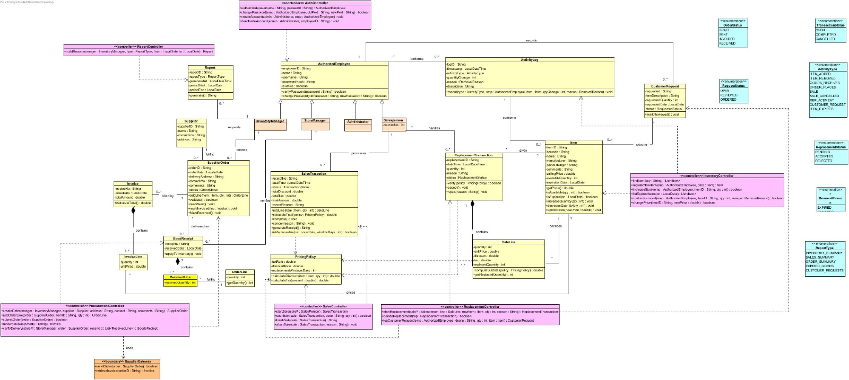
Figure 5: Class Diagram of the system
Design Principles Applied in the Class Diagram
- Responsibility assignment
We gave each operation to the class that holds the information needed to do it.
- Item owns the price and the stock, so it answers getPrice() and isAvailable(qty). No other class has to look inside it.
- SaleLine knows its quantity, price and discount, so it computes its own computeSubtotal(policy). SalesTransaction then adds the lines up in calculateTotal(policy).
- SalesTransaction and SupplierOrder contain their lines, so they create them with addLine(…).
- PricingPolicy is the only place that knows the tax rate, discount rate and replacement window. If a rule changes, only this class changes.
- Encapsulation
All attributes are private, and other classes can only use public operations.
- Item.availableQuantity is private. Only increaseQuantity() and decreaseQuantity() can change it.
- Every stock change goes through these two operations: a completed sale, a stock removal, a goods receipt or a replacement. So the quantity stays consistent whether the work is done in the warehouse or at a billing counter, as the project requires.
- AuthorizedEmployee.passwordHash is private. Other classes can only ask verifyPassword(password) and never see the stored password.
- Abstraction
- AuthorizedEmployee is an abstract class. It holds what all employees share (ID, name, username, password handling). Nobody is just an “employee”, only an Administrator, InventoryManager, StoreManager or Salesperson.
- SupplierGateway hides the external Supplier behind two operations, sendOrder() and retrieveInvoice(). The rest of the system doesn’t need to know how the Supplier works, and the project says not to design the Supplier’s system.
- Enumerations such as TransactionStatus limit a status to a fixed list (OPEN, COMPLETED, CANCELLED).

- Modularity
The system is divided into small groups of classes, matching the DFD.
- Each controller handles one DFD process: AuthController(1.0), InventoryController(2.0), ProcurementController (3.0), SalesController (4.0), ReplacementController(5.0) and ReportController (6.0).
- Controllers only coordinate. They receive a request and pass it to the entity classes, which hold the business rules, and because of this, changing how reports work doesn’t affect sales, and the classes show a clear low-coupling, high-cohesion split.
- – Inheritance: the four employee roles share the same login data, so they inherit from AuthorizedEmployee instead of repeating it. The inheritance has no multiplicity.
- Composition: we used it for SupplierOrder- OrderLine, Invoice- InvoiceLine, GoodsReciept- ReceivedLine and SalesTransaction- SaleLine. A line has no meaning without its parent and is deleted with it.
- Association: Item is only associated with these lines because an item exists on its own.
- Aggregation: we didn’t use it, because no part-whole relationship here is shared in a way that makes the model clearer.
- Association classes: the “line” classes resolve many-to-many relationships, such as many orders containing many items.
- Patterns
We didn’t force any design pattern. The controller classes follow the Controller idea (one class coordinates a use case), and SupplierGateway follows the Gateway idea (one class is the only link to an external system).

- Scrum & GitHub Project Management
8.0 Sprint Planning and Retrospective
The project was delivered across two sprints. Sprint 1 (Sep 26 – Oct 5, 2026) focused on the DFD groundwork: Level 0, Level 1, and Level 2 diagrams plus supporting flow tables, completed by Rana. This sprint overlapped with midterm exams for all team members, which significantly limited available time, so most progress came from a single member working individually.
For Sprint 2 (Oct 6 – Oct 16, 2026), the team applied a direct improvement from Sprint 1's retrospective: once exam pressure eased, the team reconvened on Oct 13 to review the DFD work together, correct it collaboratively, and immediately split the remaining tasks among members. Hanin, Jawaher, and Reem began actively working on their assigned parts (Use Case Diagram, Use Case Specifications, Class Diagram, OO explanation) in parallel rather than sequentially, starting Oct 13–14.
GitHub Repository: https://github.com/HaninAhmed/Team-B51-G04
GitHub Project (Scrum Board): https://github.com/users/HaninAhmed/projects/2/views/1
8.1 TODO process:
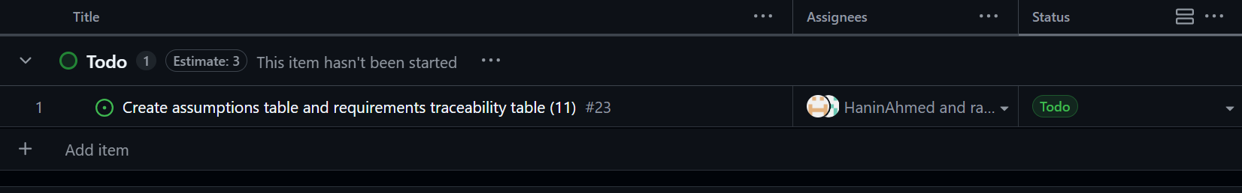
8.2 In-progress process:
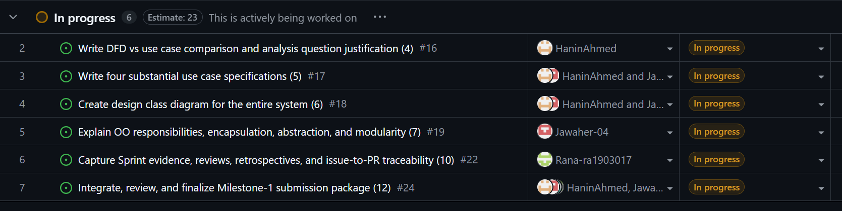
8.3 Done process:
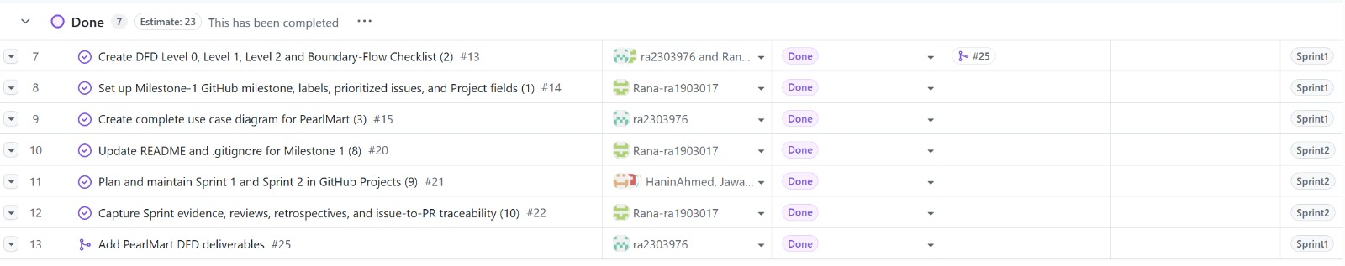
9-Assumptions & Requirements Traceability:
9.1 Assumptions
ID | Assumption | Justification | Affected models
A1 | Each employee has exactly one role: Administrator, Inventory Manager, Store Manager, or Salesperson. All are specializations of Authorized Employee. | The project description lists four employee types, each with different responsibilities. | UC, CD
A2 | Only the Administrator creates and deactivates user accounts. A deactivated account cannot log in. | The project description says the Administrator manages important system changes. It does not say who creates accounts. | UC, DFD 1, CD
A3 | Login uses a username and password. Passwords are stored only as hashes. There is no multi-factor authentication. | The project description only requires username and password verification. | DFD 1, CD
A4 | Every item has a unique item ID and barcode. Expiration date is optional and left empty for non-perishable goods. | The project description says the expiration date applies “when applicable”. | CD, DFD 2.
A5 | Adding item and stock, removing stock, and viewing expired items are done by the Inventory Manager. Updating item info (e.g., price) is done by the Administrator or Inventory Manager. Searching is done by the Salesperson or Inventory Manager. | The project description says “Authorized employee” without specifying roles, so permissions are narrowed to match the use case diagram. | UC, CD
A6 | If a scanned barcode matches an existing item, its quantity is increased. Otherwise, a new item record is created. | The project description describes this exact rule for arriving goods. | UC, DFD 2, CD
A7 | An item is expired when its expiration date is before today. Expired goods are not removed automatically. The employee must confirm the removal | The project description says the employee “may then remove” expired goods. | UC, DFD 2, CD
A8 | A stock removal is only allowed if the requested quantity is available. Every removal records the employee, reason, quantity, time, and a reason: EXPIRED, DAMAGED or OTHER. | The project description requires an availability check and recording of the change. | UC, DFD 2, CD
A9 | A supplier order goes to one supplier and has at least one order line. Its status moves through DRAFT -> SENT-> INVOICED-> RECEIVED | The project description describes the order, invoice and receipt sequence but not the states. | UC, DFD 3, CD
A10 | The Supplier is external. Communication goes only through the SupplierGateway boundary (send order, retrieve invoice). The supplier’s internal processing is not modeled. | The project description explicitly excludes the supplier’s internal operations. | DFD 0/1 , UC, CD

A11 | One order can be delivered in several goods receipts (partial deliveries). Inventory is increased only after the Store Manager verifies the received quantities. | This is the multiplicity in the class diagram (order 1 to 0..* receipts) | UC, DFD 3, CD
A12 | Each sale has a status OPEN, COMPLETED or CANCELLED. Inventory is deducted only when the sale is COMPLETED. | The project description says quantities must not be permanently deducted if the receipt is cancelled. | UC, DFD, CD
A13 | A cancelled sale is kept as a record with a cancellation reason. It is not deleted. | The project description says the system records information about cancelled transactions. | DFD 4, CD
A14 | One PricingPolicy gives the tax rate, discount rate and replacement window (in days). It applies to all items. | The project description mentions discounts, taxes and store policy but gives no details. | DFD, CD
A15 | A replacement in only accepted if the original sale exists and the request is within the replacement window. It is then marked ACCEPTED, otherwise REJECTED. | The project description says replacements follow store policy and that the system verifies the request. | UC, DFD, CD
A16 | The returned item from an accepted replacement is not put back into sellable stock (assumed defective) .only the replacement item’s quantity decreases. | The project description does not say what happens to the returned item. | DFD, CD
A17 | A customer request for an unavailable item may or may not be linked to an existing item. Its status moves OPEN -> REVIEWED -> ORDERED | The requested item may not exist in the system yet. The Inventory Manager reviews requests when ordering. | UC, DFD, CD
A18 | Inventory-affecting events are logged with a type, employee, timestamp, and quantity change. This covers additions, removals, goods received, orders, sales cancellations, replacements, customer requests and expired goods. | The project description lists these as the activities the system must keep track of. | DFD 2/3, CD
A19 | Reports are requested by the Inventory Manager for a chosen type and date range. Types: Inventory Summary, Sales Summary, Expired Goods, Customer Requests. | The project description says “authorized managers” request summary reports without naming types. | UC, DFD, CD
A20 | There is no central database for the warehouse and the billing counters, so all locations see the same data. | The project description says the system is one integrated system and information must stay consistent. | DFD 0/1, CD

9.2 Requirements Traceability Matrix

ID | Requirements | Use Case(s) | DFD Process | Responsible Classes
R1 | Employee authentication and password change. | Login, Change Password. | 1 | AuthController, AuthorizedEmployee
R2 | User account management | Manage user accounts | 1 | AuthController, AuthorizedEmployee, Administrator
R3 | Item registration and stock addition | Add new item, Add stock quantity | 2 | InventoryController, Item, ActivityLog
R4 | Item search and information update | Search item, Update item info | 2 | InventoryController, Item.
R5 | Stock removal and expired goods handling | Remove stock quantity, View expired items, Check Available Quantity | 2 | InventoryController, Item, ActivityLog.
R6 | Supplier ordering | Place supplier order, Receive supplier order info | 3 | ProcurementController, SupplierOrder, OrderLine, Supplier, Invoice, InvoiceLine, SupplierGateway
R7 | Goods receiving good inventory update | Receive goods, Update inventory quantity | 3 | ProcurementController, GoodReciept, ReceivedLine, Item.
R8 | Customer purchase processing | Process customer purchase, Check Available Quantity, Update inventory quantity | 4 (4.1- 4.5) | SalesController, SalesTransaction, SaleLine, PricingPolicy, Item.
R9 | Cancellation of the current receipt | Cancel current receipt | 4(4.4) | SalesController, SalesTransaction.
R10 | Replacement of purchased items | Replace purchased item, Validate replacement request | 5 | ReplacementController, ReplacementTransaction, SalesTransaction, PricingPolicy, Item
R11 | Recording unavailable item requests | Record unavailable item request | 5 | ReplacementController, CustomerRequest
R12 | Activity and transaction tracking | Supports R3, R5, R7 (logged on each) | 2, 3, (D3) | ActivityLog
R13 | Management reports | Generate Management reports | 6 | ReportController, Report.

10-Conclusion:
In this milestone, we analysed and designed the PearlMart Inventory Management System. We started with the DFDs (Level 0, Level 1, and a Level 2 for the sales process) to show how data moves between the users, the Supplier, and the data stores. We checked that the three levels are balanced. Then we drew the use case diagram with 20 use cases to show who uses the system and what each user can do. We compared the two diagrams and found that the DFD is better for checking that the inventory data stays consistent, while the use case diagram is better for roles and functions.
After that, we wrote four detailed use case specifications (Process Customer Purchase, Place Supplier Order, Remove Stock Quantity, and Replace Purchased Item). We then built the design class diagram, where we tried to give each class a clear responsibility and keep the attributes private. We also listed our assumptions and made a traceability table that links the requirements to the use cases, DFD processes, and classes. We used Scrum and GitHub to plan the work in two sprints and track our progress.
While working, we learned that the diagrams must use the same names and rules, otherwise they do not match each other. This milestone gave us a clear base for the next milestones.

